
Oesophageal Physiology Report

Dr Jafar Jafari MD, PhD, AGIP

Address: 27 Tooley St, London SE1 2PR, Telephone: 079 506 588 02, e-Mail: jafar.jafari@nhs.net __________________________________________________________________________________
Physician:
Dr David Reffitt MD FRCP
Consultant Gastroenterologist
Patient:
Mr Breger, Ilia DOB 16-8-70

Procedure date: 0212/2019
Procedure: High resolution manometry and 24 hour Reflux Monitoring
Indications: weak voice (? oesophagopharyngeal reflux), gastroscopy: sliding hiatus hernia but no evidence of erosions.

Dear David,

Thank you for referring this pleasant gentleman for oesophageal physiology testing. Please see the following report and do let me know if I can be of any assistance.

Lower Esophageal Sphincter Region |  | Normal | Esophageal Motility |  | Normal
Landmarks |  |  | Number of swallows evaluated | 10
Proximal LES (from nares)(cm) | 45.8 |  | Evaluated @ 3.0 - 11.0 above LES
Distal LES (from nares)(cm) | 49.2 |  | Peristaltic (velocity ≤ 6.25 cm/s)(%) | 100
LES length(cm) | 3.3 | 2.7-4.8 | Simultaneous (vel. ≥ 6.25 cm/s)(%) | 0 | ≤10%
Esophageal length (LES-UES centers)(cm) | 26.4 |  | Failed(%) | 0 | 0%
PIP (from nares)(cm) | 48.4 |  | Evaluated @ 3.0 & 7.0 above LES
Intraabdominal LES length(cm) | 0.8 |  | Mean wave amplitude(mmHg) | 69.6 | 43-152
Hiatal hernia? | No |  | Mean wave duration(s) | 3.1 | 2.7-5.4
LES Pressures |  |  | Double-peaked waves(%) | 20 | ≤15%
Pressure meas. method | eSleeve,IRP |  | Triple-peaked waves(%) | 10 | 0%
Basal (respiratory min.)(mmHg) | 7.3 | 4.8-32.0 | Velocity (11.0-3.0 above LES)(cm/s) | 2.6 | 2.8-6.3
Basal (respiratory mean)(mmHg) | 9.8 | 13-43 | High Resolution Parameters
Residual (mean)(mmHg) | 6.8 | <15.0 | Distal contractile integral(mean)(mmHg-cm-s) | 698.9 | 500-5000
Residual (highest)(mmHg) | 8.5 |  | Distal contractile integral(highest)(mmHg-cm-s) | 979.0
Percent relaxation(%) | 58 |  | Contractile front velocity(cm/s) | 2.5 | <9.0
Upper Esophageal Sphincter |  | Normal | Intrabolus pressure (@LESR)(mmHg) | 1.8 | <8.4
Location (center, fr. nares)(cm) | 20.8 |  | Intrabolus pressure (avg max)(mmHg) | 11.5 | <17.0
Mean basal pressure(mmHg) | 27.9 | 34-104 | Chicago Classification
Mean residual pressure(mmHg) | 3.9 | <12.0 | Distal latency | 7.4
Relaxation time-to-nadir(ms) | 128 | 74-365 | % failed (Chicago Classification) | 0
Relaxation duration(ms) | 666 | 480-1020 | % panesophageal pressurization | 0
 |  |  | % premature contraction | 0
 |  |  | % rapid contraction | 0
 |  |  | % large breaks | 0
 |  |  | % small breaks | 10

HRM
Upper Oesophageal Sphincter: The UOS was and showed on wet-swallows.
Tubular oesophagus: The oesophageal body produced .
Lower Oesophageal Sphincter: The LOS was and showed on wet-swallows. There was hiatus hernia.
Diagnosis of HRM:

24 hour pH-Impedance Reflux Monitoring:
Distal Oesophagus: total: 6.4%, normal <; upright: 4.1%, normal <; supine: 8.1%, normal <; DeMeester score: 23.4, normal <14.72; : total 72,
Reflux-symptom correlations: Symp1 =belching: 184 episodes, SI=82%, SAP=100%; Positive SI >= 50%, Positive SAP >95%;
Conclusion of reflux monitoring: ;


Dr. Jafar Jafari MD, PhD | Dr T Wong MD FRCP

Swallow #1  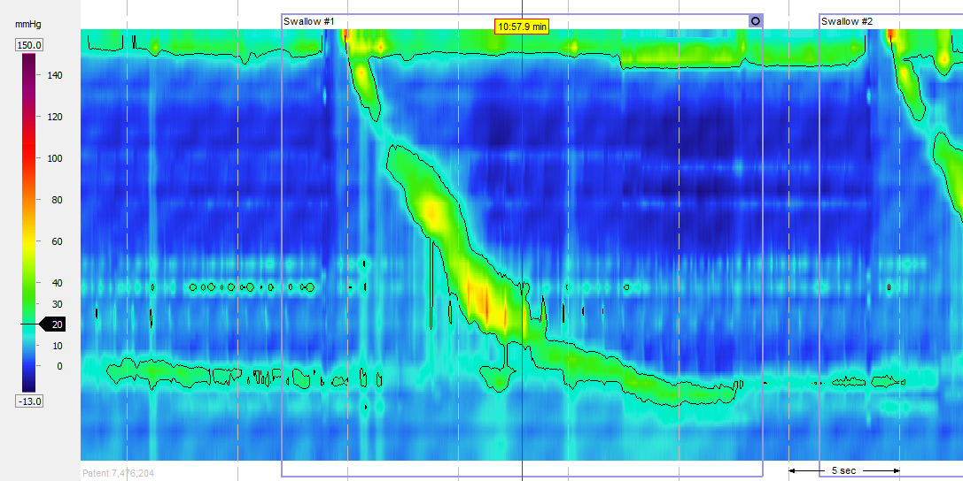 | Swallow #2  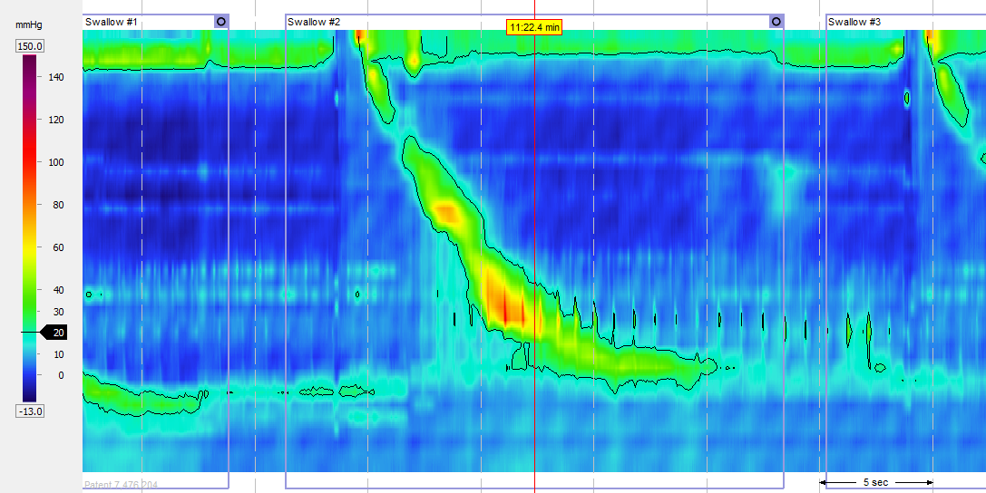
Swallow #3  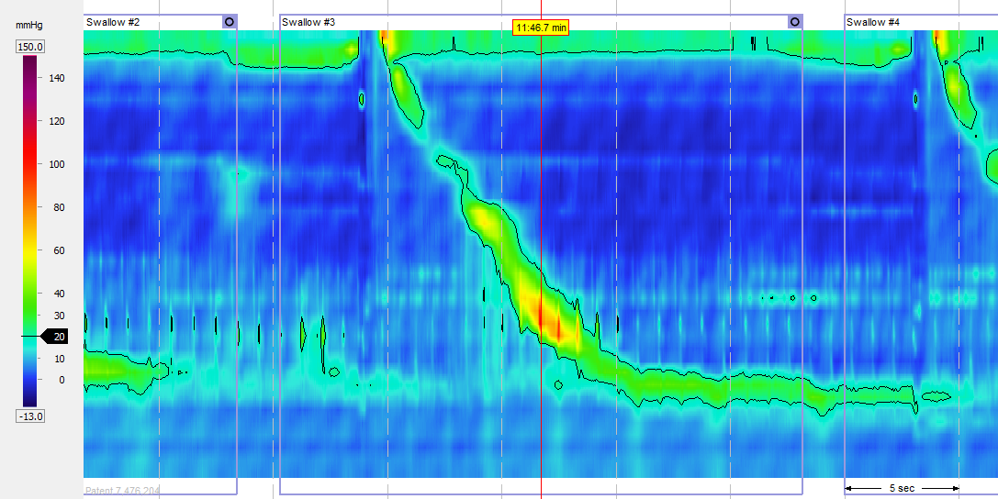 | Swallow #4  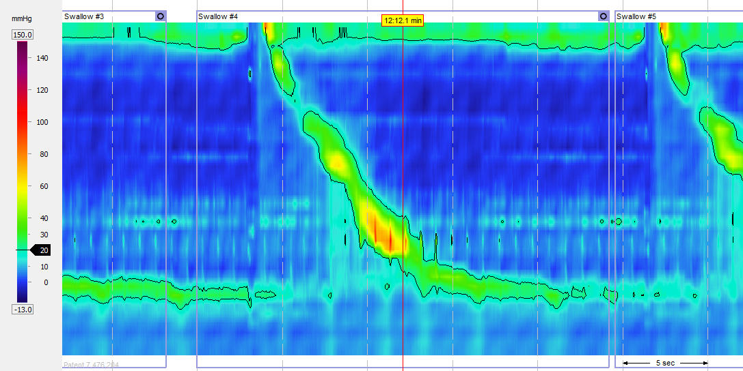
Swallow #5  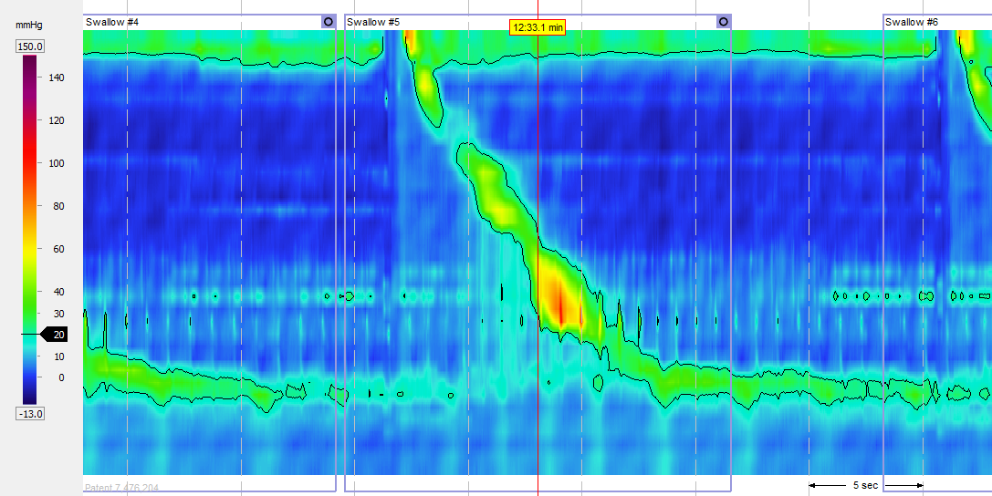 | Swallow #6  